
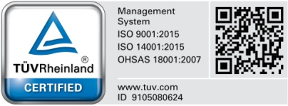
Hanna Instruments SRL
Romania, Salaj, Nusfalau, Str. Hanna, Nr. 1 Document No. MR-
Tel.: +40/260/607700; Fax: +40/260/607739
Material Requisition

Section1 : Made by From Production Line no./department :

Today

Reason of the request

Materials requested :

No. | Code | Description | CAS | Q.ty Required | Location | Specified Location

Section 1 will be filled up by production line leader.

Section2 : Processed by

Approval | Name | Signature | Department | Name | Signature
Department Manager
General Manager

Section 2 will be filled up by warehouse and planning responsibles

